

CIT 336 Enhancement 1 INSTRUCTIONS & RUBRIC

Purpose

This enhancement is a review of the concepts, skills and techniques that should have been learned in CIT 230 - Web Frontend Development. It requires you to build a template and home page from that template for a ficticous web site - Acme, Inc.

Notice!

All html and css must be of your own creation. No outside templates or frameworks are acceptable for this enhancement or future enhancements in the course.

Video Overview

This video provides a brief demonstration of what your finished enhancement should look like and how it should behave once done with the enhancement.

Assumptions

This enhancement assumes that you can code semantic and valid HTML5, CSS3 (including the use of media queries and responsive layouts) and implement the basic design principles of Proximity, Alignment, Repetition and Contrast. In addition, basic usability concepts can be implemented readily. The review materials listed in the overview page are meant to help brush up with these skills as needed.

Download

A zip file containing a base folder along with subfolders of [starter assets should be downloaded](https://blainerobertson.github.io/336d2lv2/downloads/acme.zip), unzipped and placed in your htdocs folder. All subsequent work with the Acme web site will be performed here.

Tasks

Build a Template

You are to build a generic template for the Acme web site (a template contains no content, it is a resource from which actual content pages, known as views, can be built). See the illustration below:  
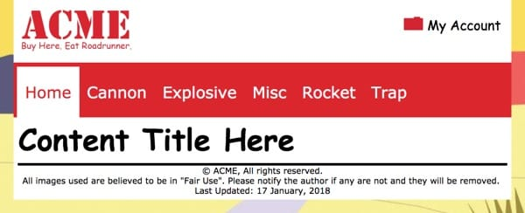

The template must:

1. use the .php file extension,
2. use HTML5 semantic structures (header, nav, main and footer) for page sectioning,
3. include the viewport meta element,
4. include the **media="screen"** attribute for the css link element,
5. use the color scheme shown: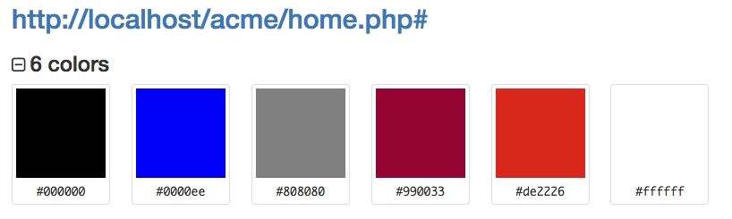
6. use fonts of your choice, but they should fit the cartoon look and feel,
7. be fully responsive to a variety of devices so that the content loads without horizontal scrolling or zooming (see the video illustration below),
8. use usability concepts, the minimum expectations are:
   * links contain title attributes
   * images contain alt attributes
   * fonts are easily read and contain clear contrast between background and foreground colors
   * headings form a meaningful document outline with no levels being missed
9. use external CSS for all styling. The CSS must:
   * be stored in the provided css folder,
   * start with a mobile first approach,
   * be responsive to varying screen sizes of a variety of devices,
   * use media queries for responsive layout only for larger screen sizes,
10. use modularization for common content (e.g. page header, navigation and footer) by:
    * Creating a "common" folder to store the common content code snippets (modules).
    * Create a separate code snippet for the acme header, navigation and footer and store each into the "common" folder.
    * Follow the directions in the "Modularizing Common Content" activity to implement the modules into the template.
    * Be sure to thoroughly test that the code from the code snippet modules get delivered to the template file, and later to the actual web pages (views) that you build using the template.
11. weigh less than 400Kb total weight, and
12. be valid HTML5 and CSS3 code.

Build the Acme Home View

Having built the template, you will now use it to build the Acme home view. The view must:

1. be named "home.php" and be stored at the root of the **acme** folder,
2. contain the content as shown in the images below (a text file with the text content is included in the download) and images are found in the images folder,

A screenshot of a social media post

Description generated with very high confidence

***Acme home - Large Screen***

*A screenshot of a cell phone

Description generated with very high confidence*

***Acme home - Mobile Screen***

1. Write your CSS to position the page content to match as closely as possible the provided images of the home.php view in both large screen and mobile screen layouts.

Submission

* Build and test your code in the XAMPP development environment.
* Work with your learning team to accomplish the task and post to and read the weekly discussion board to help one another.
* Check your work to ensure that it meets all of the expectations listed.
* When satisfied that the code is operational:
  1. Create a short video of the template AND home page. Include in the video:
     1. both the template and home page as they appear in the browser.
     2. a demonstration of the responsiveness of the home view in a browser.
     3. a demonstration of the validity of the HTML5 and CSS3 of the home view in the browser.
  2. post your video to your YouTube channel and copy the link to the video when published.
  3. zip the acme folder and name it enhancement 1 (save this zip file outside of your web site)
  4. submit the zip file to the enhancement 1 assignment dropbox and add the video URL to the dropbox comment.

Grading Matrix

Use the grading items below to pre-grade your work as these are the exact grading items the professor will use to grade the work.

* Both files (template and home) use the php extension: **2 points**
* The home view uses modularization for common content: **3 points**
* The home view uses semantic structures (header, nav, main, footer): **3 points**
* The home view is valid HTML5: **4 points**
* The home view is responsive across devices with no zooming or horizontal scrolling required to view content (including images): **4 points**
* All CSS is external (no internal or inline CSS is found): **2 points**
* The content headings in the home page form a meaningful outline with no skipped levels: **2 points**
* The usability standards mentioned above are found in the home page: **4 points**
* Both the template and home page are fully operational with no broken text, links, images or other content: **4 points**
* The video of the finished project is present and shows both view, responsiveness and validity as required: **2 points**
* Total value: **30 points** - all in objective 1